Lesson 5: Is there a similar mathematical relationship between the masses and the changes in velocity for two objects in any other collision conditions?

Previous Lesson | We analyzed data collected from speed and force sensors for two carts during several collisions. We develop a series of mathematical representations to describe quantitative patterns we noticed between the masses and the changes in velocity of the two carts.
This Lesson  Investigation  2 days   | 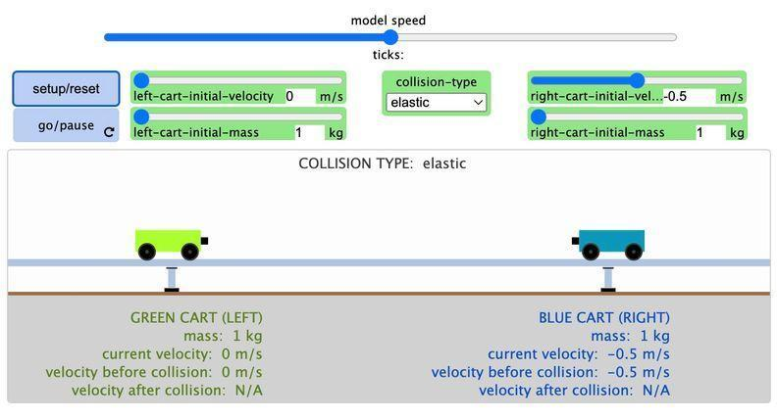 | We collect data from a simulation and use it to argue for whether the relationships we discovered from analyzing the videos and graphs hold for any other collision conditions. We develop and use alternate algebraic models to solve for the mass or velocity of an object before a collision.
Next Lesson | We will use a controlled environment of a cart going down and up a ramp to investigate the relationship between the net force being applied on the cart, and the time over which this force is applied. We will use a visual representation to analyze how these two variables interact to cause the changes in momentum we observed, and to identify the mathematical pattern to the change in momentum. We will develop a mathematical model that integrates force, time, and change in momentum.

BUILDING TOWARD NGSS  HS-ETS1-3, HS-PS2-2, HS-PS2-3, HS-PS2-1   | What students will do  5.A Apply techniques of algebra to represent and describe the conservation of momentum in a system of two objects and solve for an unknown condition or outcome (SEP: 5.3; CCC 4.2; DCI: PS2.A.2).  What students will figure out  - The momentum of an object is the product of its mass and its velocity.  - The total momentum of two objects in a collision is conserved when there are no small external forces on two objects during a collision; momentum conservation provides a close approximation of the outcomes, when the external forces on the objects (e.g. friction) are much smaller in magnitude than the average collision force.

Lesson 5 • Learning Plan Snapshot
Part | Duration |  | Summary | Slide | Materials
1 | 3 min |  | NAVIGATE  Identify what we were wondering about the symbolic relationship we developed at the end of the last class. | A
2 | 17 min |  | TEST OUR IDEAS WITH A SIMULATION AND COMPARE RESULTS  Use a simulation to collect data on one inelastic and one elastic collision and calculate the ratio of changes in velocity from the results on a whiteboard. Compare calculations across groups. | B-D | Calculator, Whiteboard, whiteboard markers, paper towel or whiteboard eraser, https://openscied-static.s3.amazonaws.com/HTML+Files/Inelastic+and+Elastic+Collisions.html, computer, Mathematical relationships in our collisions poster, markers
3 | 8 min |  | SIMPLIFY TO REVEAL A CONSERVED QUANTITY  Simplify the equation to have no fractions. Identify that there is a quantity in the simplified equation that appears to be conserved. Recall other examples of conserved physical quantities. | E-F | Calculator, Whiteboard, whiteboard markers, paper towel or whiteboard eraser, Mathematical relationships in our collisions poster, markers
4 | 13 min |  | USE GEOMETRIC REPRESENTATIONS  Develop a geometric model using rectangles to represent the conserved quantity in different collision scenarios. Evaluate the affordances and limitations of the geometric model. | G-I | Markers
5 | 4 min |  | INTRODUCE CHANGE IN MOMENTUM  Annotate the equation as showing a relationship for the change in momentum. |  | poster paper, markers

End of day 3
6 | 2 min |  | NAVIGATE  Summarize how the change in momentum equation developed last class is related to what we’ve seen in our data so far. |  | Momentum relationships poster.
7 | 9 min |  | DEVELOP AN ALTERNATE FORM OF OUR EQUATION  Problematize what momentum is. Rewrite the equation to identify momentum for four different parts of the collision system. Identify limitations of the equation. | J | Calculator, Whiteboard, whiteboard markers, paper towel or whiteboard eraser, Momentum relationships poster, markers
8 | 5 min |  | USING OUR EQUATIONS TO MAKE A PREDICTION  Individually use the equation to solve for an unknown and use it to make two predictions. | K | Calculator, Momentum relationships poster, markers
9 | 5 min |  | ADD TO PERSONAL GLOSSARIES  Add delta (Δ), elastic collision, inelastic collision, momentum  to personal glossaries. | L
10 | 9 min |  | PREDICTING OUTCOMES ACROSS A BROADER SET OF COLLISION PHENOMENA.  Orient to the distribute handout to every student | M | Three Momentum Cases, calculator, Momentum relationships poster, markers
11 | 9 min |  | SELF-ASSESS AND REFLECT  Use a key to self-assess understanding; reflect on confidence using different approaches to using conservation of momentum to solve for an unknown condition or outcome. | N | Momentum Self Assessment, calculator, notebook., Momentum relationships poster, markers
12 | 6 min |  | NAVIGATE  Use the slide prompt to get students thinking about how change in momentum might be related to the force applied to an object, and/or the time over which the force is applied. | O | Momentum relationships poster, Relationships between variables for 2 colliding objects poster

End of day 4

Lesson 5 • Materials List
 | per student | per group | per class
Lesson materials | - Calculator  - notebook  - Science notebook  - Three Momentum Cases  - calculator  - Momentum Self Assessment  - notebook. | - Whiteboard  - whiteboard markers  - paper towel or whiteboard eraser  - https://openscied-static.s3.amazonaws.com/HTML+Files/Inelastic+and+Elastic+Collisions.html  - computer | - Mathematical relationships in our collisions poster  - markers  - Markers  - poster paper  - Momentum relationships poster.  - Momentum relationships poster  - Relationships between variables for 2 colliding objects poster

Materials preparation (15 minutes)

Review teacher guide, slides, and teacher references or keys (if applicable).

Make copies of handouts and ensure sufficient copies of student references, readings, and procedures are available.

Display the Mathematical relationships in our collisions poster from the prior lesson.

Test the simulation students will use:
- https://openscied-static.s3.amazonaws.com/HTML+Files/Inelastic+and+Elastic+Collisions.html

Lesson 5 • Where We Are Going and NOT Going

Where We Are Going

This lesson is designed to coherently build ideas related to the following disciplinary core idea:
- PS2.A.2: Forces and Motion. Momentum is defined for a particular frame of reference; it is the mass times the velocity of the object. (HS-PS2-2)

The idea that models have limitations, but can still provide useful approximations, is a fundamental part of the high school level SEP elements 2.2 and 2.4. But in this lesson they are being applied at a middle school level, so we have not claimed these elements here. Students build off prior work in this unit and across units related to idealized conditions and limited data to develop explanatory models of phenomena.

This lesson provides an opportunity to make connections across courses if students have taken the OpenSciEd chemistry course, by discussing how the incrementally derivation of a suspected algebraic relationship is reminiscent of what they did in OpenSciEd Unit C.1: How can we slow the flow of energy on Earth to protect vulnerable coastal communities? (Polar Ice Unit) to derive thermal energy transfer and conservation of energy relationships.They have also used a similar approach for the efficiency of energy transfer systems in OpenSciEd Unit P.1: How can we design more reliable systems to meet our communities’ energy needs? (Electricity Unit) and relative amounts of different matter due to radioactive decay over time in OpenSciEd Unit P.2: How forces in Earth’s interior determine what will happen to its surface? (Earth’s Interior Unit).

Students will be interpreting the structure of an equation, identifying ways to rewrite it, and rearranging it to highlight a quantity of interest. Talk with your math teachers to identify prior experiences that students have had with these related CCMS ideas, identified in further detail, at the end of this teacher guide.

Where We Are NOT Going

Do not give students the words momentum before they get a chance to co-develop the concepts in context. The lesson is purposefully designed so that students are motivated to keep track of the quantity of mass times speed and notice that it is conserved in collisions, before assigning a scientific term. It is only after getting multiple lines of evidence for such a conserved quantity, that it is named as momentum in this lesson.

Historically, scientists debated whether momentum or kinetic energy were more useful and/or sufficient for explaining many phenomena. It was only after many years of debate that they decided they needed both. No attempt is made to apply kinetic energy related equations in this lesson, nor conservation of energy relationships. If students ask about whether momentum and energy are the same thing, say “that is a really good question” and suggest that we keep exploring. Students will start discussing energy connections in lessons 9 and 11, and will apply quantitative measures of kinetic energy in the next unit OpenSciEd Unit P.4: Meteors, Orbits, and Gravity (Meteors Unit).

LEARNING PLAN for LESSON 5
1 · NAVIGATE | 3 min
MATERIALS: None
Identify the questions we were considering at the end of last class. Display slide A. Discuss the related question about the equation shown on the slide as a class.

Suggested prompt | Sample student response
What were we wondering about this mathematical relationship at the end of our last class? | We were wondering if this relationship holds for other mass ratios besides 2:1 or 1:2.  Or whether it holds for when both carts are moving before the collision  Or whether it applies when the collision is inelastic.

Motivate testing additional conditions. Say, Let’s orient to a sim that you can use that will allow you to play around with all kinds of combinations to see if this relationship holds for any other collision conditions. You will need your whiteboard or a sheet of paper, a calculator, and a pencil or pen to do the calculations using the data you collect from the simulation.

ADDITIONAL GUIDANCE | The equation on slide A, uses new subscripts for the variables. It now uses A and B to represent any object, rather than G and B, which had been abbreviations of the green cart and blue cart.  If students note this switch, make note of this rationale as a way to help us think about what relationships might (or might not) hold for any collision between any two objects.

2 · TEST OUR IDEAS WITH A SIMULATION AND COMPARE RESULTS | 17 min
MATERIALS: Calculator, notebook, Whiteboard, whiteboard markers, paper towel or whiteboard eraser, https://openscied-static.s3.amazonaws.com/HTML+Files/Inelastic+and+Elastic+Collisions.html, computer, Mathematical relationships in our collisions poster, markers
Orient to a new simulation. Display slide B. Point out the following interface elements that students can change in the simulation:
- The two sliders that allow students to change the starting velocity of each cart.
- The two sliders that allow students to change the mass of each cart.
- The chooser that allow students to change the type of collision (elastic or inelastic)
- The SETUP/RESET button which initializes a new model run using the values set in the sliders and chooser above.
- The GO/PAUSE button that runs the model to produce the outcomes of the collison.

Carry out an investigation. Display slide C. Review the directions on the slide. Share the url for the simulation with students: https://openscied-static.s3.amazonaws.com/HTML+Files/Inelastic+and+Elastic+Collisions.html . Have students work with partners to carry out this brief investigation and record the related data. As students are doing this, distribute a white board, 2 white board markers, and a paper towel or whiteboard eraser to each partner.


Test our model. Pause students working with the simulation. Display slide D. Read through the directions. Tell students to use their calculators and to prepare documentation of their calculations on their whiteboard, so they will be easily visible to share these with the whole class in a few minutes.

Bring the class together to share whiteboard results for 5 minutes. Ask, Does the mathematical relationship we discovered for Collisions E and F hold for none, some or all the collisions we tested as a class? What do your results say? Students should come to an agreement that it holds for all the conditions they tested.

ASSESSMENT OPPORTUNITY | What to look/listen for in the moment: Documentation of testing the equation for collisions in a system of two objects, which should include each of the following elements:  - writing the symbolic equation for a system of two objects we developed as a class (mV + mV = mV + mV) (CCC 4.2; DCI: PS2.A.2)  - substitution of data into all the variables in the equation (SEP: 5.3)  - one or more steps to keep track of products and/or sums of the resulting values on each side of the equation. (SEP: 5.3)  - the result should show that both sides of the equation are equal. (DCI: PS2.A.2)  What to do: Invite students to use evidence from their simulation findings to support their arguments about whether the mathematical relationships the class has developed earlier hold for none, some, or all collisions. Invite students to agree or disagree with other groups in order to uncover potential misconceptions and to make student thinking visible to others.  Building Toward 5.A.1 Apply techniques of algebra to describe the conservation of momentum in a system of two objects and solve for an unknown condition or outcome (SEP: 5.3; CCC 4.2; DCI: PS2.A.2).

ADDITIONAL GUIDANCE | If some students' results indicate this relationship doesn’t hold, it will most likely be due to an undetected error in their record keeping of the data or in their calculations. To help uncover this error as a class and still honor the implications of these initial conclusions, modify the statement in the next section to say “most collisions”. Suggest that we try to figure out what might be different about these collision conditions that led the results to not be equal.  You can then do one of the following: a) explore those collision settings in the simulation again as a class or b) ask interested students to investigate these to figure out why they might be producing a different outcome. This can be something that is done as home-learning. Either of these will end up uncovering that there must have been an error in earlier work, and the relationship does hold for all the cases in the simulation.

3 · SIMPLIFY TO REVEAL A CONSERVED QUANTITY | 8 min
MATERIALS: Calculator, notebook, Whiteboard, whiteboard markers, paper towel or whiteboard eraser, Mathematical relationships in our collisions poster, markers
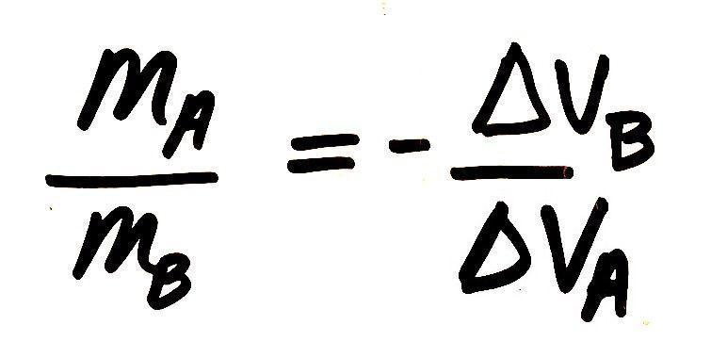
Simplify our equation. Point to the equation at the front of the room that equates the ratio of velocity changes to the negative, reciprocal for the ratio of their masses (pictured at right, top). Present slide E. Remind students that fractions are not always the easiest way to work with quantities. Ask students to work with a partner quickly to try to simplify the equation to move some of the variables out of the denominator.

Give students about two minutes to work this out on their whiteboards with a partner and then ask students to share out. On the board, as students share out, document the process of cross-multiplying to get the equation at right, center.

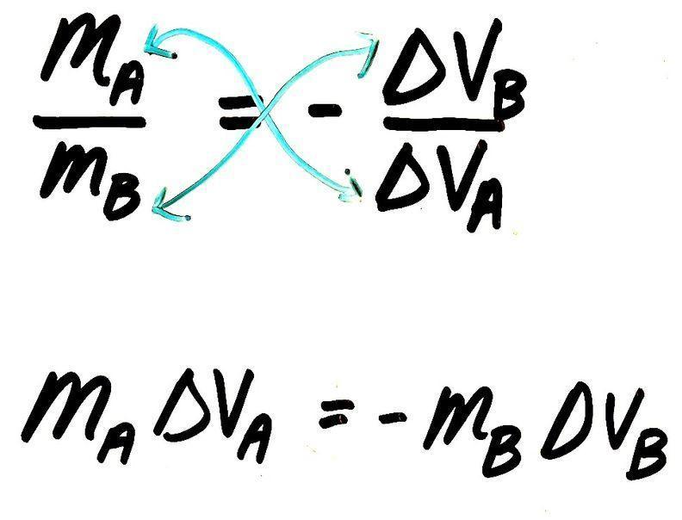
Summarize the equation and point out that there is a quantity that is conserved. Say, We have an equation here that fits our data, that shows us that in a collision, the change in velocity times the mass of the first vehicle is always going to be equal to the change of velocity times the mass of the second vehicle, but in the other direction, which is what the negative sign tells us. So the mass times velocity lost by the blue vehicle in this case, is going to be gained by the green one. That tells us that for this quantity we have been calculating, nothing has been lost from the system. And we can show that more clearly by moving all of the variables to one side of the equation and seeing that the total change across the system is zero.

Move the negative term to the other side of the equation at the front of the room, as shown at right, bottom.


Say, We have figured out that this quantity, mass times velocity, is conserved in a collision when we keep track of it for both objects in the system that collide with each other.

Turn and Talk briefly about conserved quantities. Present slide F. Give students under a minute to identify some other physical quantities that are conserved. Listen in, and then tell students, I heard ideas about conservation of energy, and mass. We definitely used those ideas in earlier units! And now we have found something else that is being conserved.

4 · USE GEOMETRIC REPRESENTATIONS | 13 min
MATERIALS: Markers
Develop a geometric representation. Say, Whenever we think about a conserved quantity in any physical process, it can be useful to try to represent that quantity using alternate visualizations beyond just numbers or symbols. Let’s try to visualize this quantity that is being conserved with a geometric model. A geometric model uses geometry, or shapes, to represent quantities in from an alternate representation visually. So we need a shape that will help represent a quantity that is the product of two variables. Present slide G. Cue students to Turn and talk to a partner about the related question on the slide:  - What are some shapes you’ve used to represent the quantity that is the product of two variables in the past?  Give students a minute to talk with a partner as you wander around the room. Then say, I heard some shapes being suggested. One of those was a rectangle. Can someone tell me how the product of two variables can be represented by a rectangle? Look for ideas about how they have a base and a height and how the product of these represents their area.  If this idea doesn’t come out, or need further clarification, say something like, The product of two values can be conceptualized as the area of a rectangle where the base and height represent the values.  Let’s try and represent a certain amount of change in this quantity that a vehicle undergoes in a collision using a rectangle, where one side of the rectangle will represent its mass and the other side will represent its change in velocity.  Draw a rectangle with the variables on its sides as shown and the corresponding description.  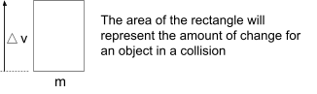  Represent the amount of change for one object. Let’s consider a situation where a 3 kg cart is stationary before a collision and it had a speed of 4 m/s after the collision. Present slide H. Ask students how to represent the amount of change using this geometric representation. Anticipated responses:  - draw a rectangle with a base of 3 and a height of 4  - it will have an area of 12, which represents the amount of change that object experiences.  Sketch and annotate the corresponding rectangle on the board:  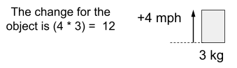  Ask students to consider how much the velocity of the second cart should have changed if it had a mass of 6 kg. Students should say it should have changed by 2 mph. Sketch and annotate the corresponding rectangle on the board next to the first in red marker:  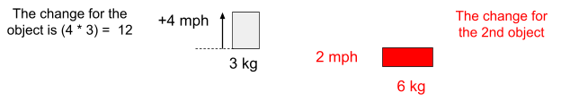  Ask students whether the change is an increase or decrease for this object if we know the sum total of the changes in the entire system has to be zero. Students will say it should be a decrease.  Suggest that we show a decrease by drawing the arrow going in the other direction from the reference line drawn at the top of the rectangle, so we can better visualize this as a decrease in the amount of this quantity for this second object. Add negative signs to the annotations as well to represent the change in velocity as -2 mphs, and the change in the second object as -12.  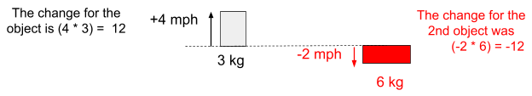  Represent the amount of change for a different second object. Ask students how we would draw this rectangle if the mass of the second cart was 1 kg, instead of 6. Students will say draw it as a rectangle that is 1 kg wide and goes down 12 mph from the reference line. Erase the red rectangle, its label, and calculate and redraw the following:  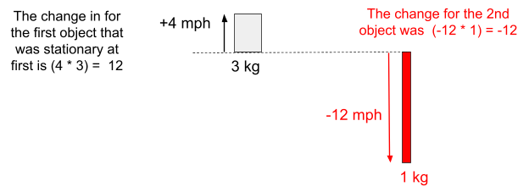  Represent the momentum change for a different second object. Ask students how we would draw this rectangle if the mass of the 2nd cart was 24 kg. Students will say draw it as a rectangle that is 24 kg wide and goes down 0.5 mph from the reference line. Erase the red rectangle, its label, and calculate and redraw the following:  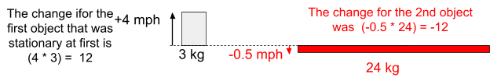  Evaluate the geometric model. Display slide I. Discuss the related questions as a class.  Suggested prompt Sample student response  What did the geometric representation help us visualize? It helped us see how two variables work together to produce the change in each object. It helped us see if one variable is really small but the other is really big, it can result in the same amount of change. It helped us see how changes can cancel out. It helped us visualize the quantity represented by the product of the mass and the change in the velocity  What were some of the limitations of the geometric representation? The overall change in the quantity when the velocity decreases, is kind of harder to visualize, because there isn’t really anything like a negative area of a rectangle. Sketching the rectangles might take more time than just sticking with symbols and numbers. | ✱ ATTENDING TO EQUITY  Universal Design for Learning  Co-developing this geometric representation of the relationship provides an alternate way of representing the patterns students have seen that is very different from the bi-variate graphs students analyzed earlier. It is also very different from the symbolic/algebraic way of representing a conserved quantity like momentum, which they will incrementally develop and refine later in this lesson.  Area constructs are ones that students have been reasoning about as conserved quantities in common core mathematics throughout much of grade school for many years, before working with symbolic representations or bi-variate graphs in later grades. These geometric representations, therefore, may help draw on some additional intuitions about why a product of two variables (which we will later name as momentum in this lesson) would either be conserved or transferred in a particular process or event (like a collision). Keep in mind that there may be challenges for some students, at first, with using such a representation in considering the idea of a “negative area”.

5 · INTRODUCE CHANGE IN MOMENTUM | 4 min
MATERIALS: poster paper, markers
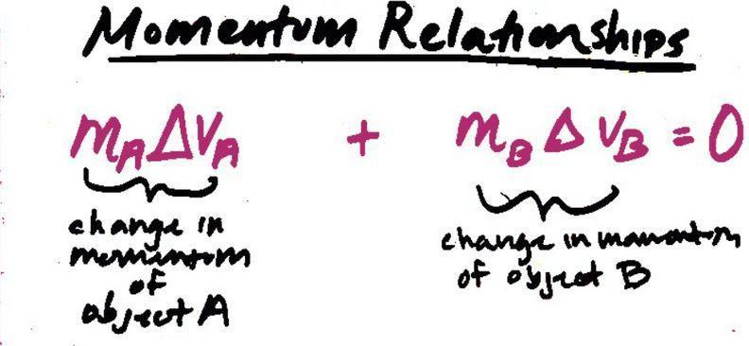
Name this quantity we are visualizing. Say, As scientists realized that this was a conserved quantity, they recognized they needed a way to that quantity more easily, so they assigned it a name. They called the quantity mass * change in velocity, a change in momentum. Add the following title and annotations on top of the prior equation you wrote. If this is your last class, start recording all of this on one poster paper, which you will reference in future activities and lessons as the Momentum relationships poster.

End of day 3
6 · NAVIGATE | 2 min
MATERIALS: Momentum relationships poster.
Refer to the Momentum relationships poster you made last period. Ask students to explain to a partner in their own words how this equation is related to what we’ve seen in our data so far.

7 · DEVELOP AN ALTERNATE FORM OF OUR EQUATION | 9 min
MATERIALS: Calculator, notebook, Whiteboard, whiteboard markers, paper towel or whiteboard eraser, Momentum relationships poster, markers
Problematize what momentum is. Say, even though we have a relationship represented here that describes momentum change in collision that can account for our results, this raises a new question. If what is on the left side of the equation represents change in momentum in each object, then what exactly is momentum itself? Present slide J. Read the text on the slide, If m * Δv is change in momentum, then let’s consider what momentum itself is, by first thinking about what the Δ represents. Then discuss the related question as a class.

Suggested prompts | Sample student responses | Follow-up questions
How did we use data to determine the change in a single variable (i.e. Δt, Δv)? | We determine the difference between two points in time.  We determine the difference between two velocities. | So how many measurements do we need to determine change in the thing we are measuring.

Substitute in final and initial velocities for Δv. Say, Since Δv can be determined by subtracting the initial velocity from the final velocity, let’s substitute variables for those two different velocities in for Δv, and rewrite our conservation side; Let’s substitute symbols to represent the final and initial velocities for Δv. Add a new equation to the board, next to the Momentum relationships poster. If this is your first class, and add it to the Momentum relationships poster if it is your last class. | 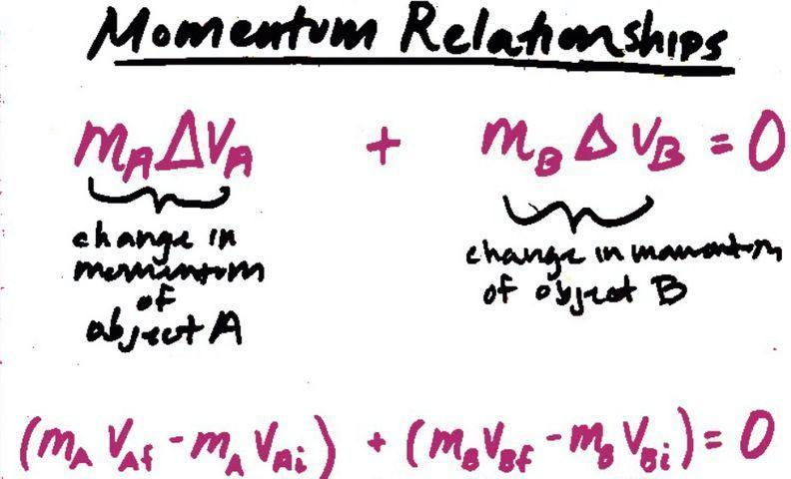
Rearrange terms. Say, If we distribute the terms we get to see that there are times in the system where the mass is being multiplied by the velocity. Each of these are a measure of the momentum of that object at a different point in time. Add a new equation to the board and label it, next to the Momentum relationships poster. If this is your first class, and add it to the Momentum relationships poster if it is your last class. | 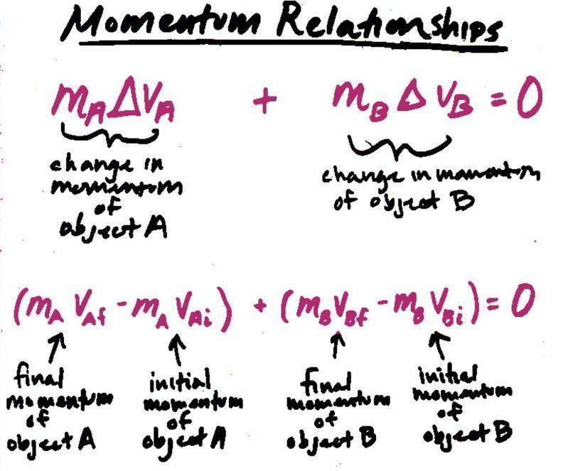
Introduce the limitations of these equations. Explain that all of these equations show different ways to represent and think about the conserved quantity of momentum in a system and that you can use any one of them to make predictions about the outcome of many collisions. Say, Scientists have found that these relationships hold when there are no external forces acting on two objects during a collision other than their contact forces on each other and they also find it provides a very useful approximation of the predicted outcome of any collision between two objects where there are relatively small external forces acting on the objects in the system. This is the case for systems where external forces from friction with the road or track or air resistance is relatively weak compared to the contact forces between the objects that are colliding, which was the case in collisions A-F and is also the case in most vehicle collisions. Add a related qualification below the equations on the board, next to the Momentum relationships poster. If this is your first class, and add it to the Momentum relationships poster if it is your last class. | 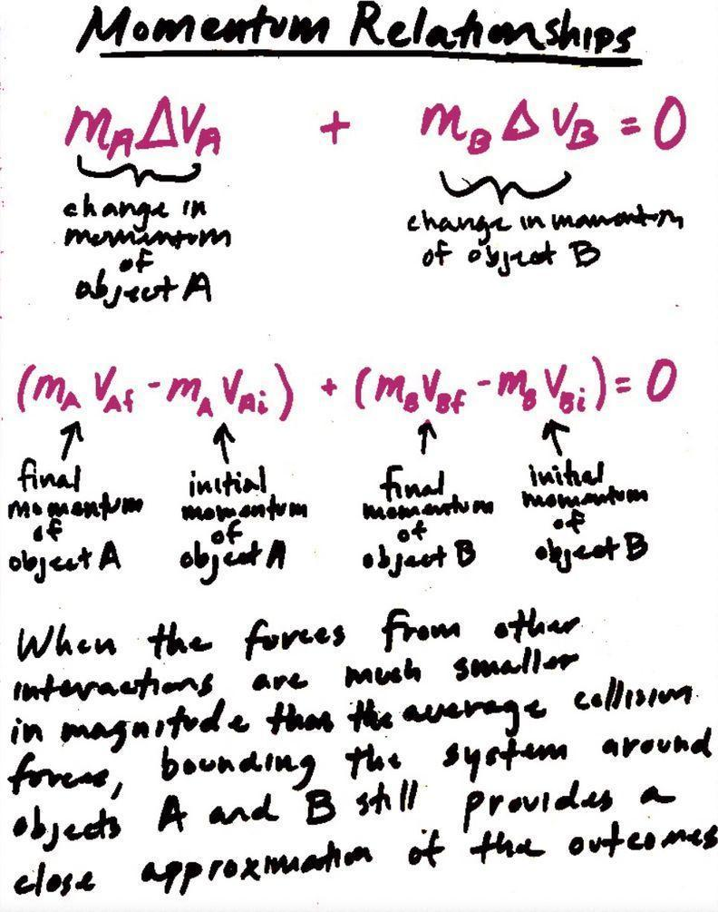

8 · USING OUR EQUATIONS TO MAKE A PREDICTION | 5 min
MATERIALS: Calculator, notebook, Momentum relationships poster, markers
Use the equation to predict the outcome of a vehicle collision. Say, Now that we know we can use any of these mathematical models to make predictions, let's see what it would predict for a real-world rear-end collision, between a moving truck and a stationary car. Display slide K. Instruct students to use their notebook to solve for this unknown. This should take just under 3 minutes for students to be ready to share their answers.


Compare answers. Students should agree that the velocity of the car after the collision is predicted to be 45 mph and the change in the velocity of the car should be 42 mph.

ASSESSMENT OPPORTUNITY | What to look/listen for in the moment:  - Students should record the conservation of momentum equation for a system with two objects. (CCC 4.24; DCI: PS2.A.2)  - Students should substitute all but one of the variables in one of the equations with the values:(SEP: 5.3)  - If solving for v: 6000 kg, 30 mph, 23 mph; 1000 kg, 3 mph, X mph  - If solving for Δv: 6000 kg, -7 mph; 1000 kg, X mph  - Students should document one or more algebraic steps to keep track of order of operations, or balancing the equation to solve for the unknown variable. (SEP: 5.3)  - The resulting solution should be for the final velocity of the car should be 45 mph and the change in the velocity of the car should be +42 mph. (SEP: 5.3)  What to do: If students are struggling with this collision problem, ask them to compare their notebooks' documented steps to finding a solution with a new partner. Use Three Momentum Cases to check whether these students can solve additional collision problems.  Building Toward 5.A.2 Apply techniques of algebra to describe the conservation of momentum in a system of two objects, solve for the velocity and change in velocity of an object, and compare these predictions to the earlier patterns we noticed in smaller mass cart collisions. (SEP: 5.3; CCC 4.2; DCI: PS2.A.2)

If time permits, follow-up by asking students how the ratio of the velocity changes compares to the ratio of the masses and how these compare to our earlier discoveries from the green and blue collision carts.

Suggested prompt | Sample student response
How does the ratio of the velocity changes compares to the ratio of the masses | The ratio of the velocity changes are the negative reciprocal of the ratio of the masses.
How does this compare to our earlier discoveries from the green and blue collision car? | This is the same relationship we were predicting earlier from the 2/1 vs. -½ ratios.

9 · ADD TO PERSONAL GLOSSARIES | 5 min
MATERIALS: Science notebook
Present slide L and give students time to add words and symbols they developed in this lesson to their personal glossaries. Some of the words students may decide to include are: delta (Δ), elastic collision, inelastic collision, momentum.

ADDITIONAL GUIDANCE | If students ask whether they should add the equations developed in this lesson to their glossary as well, say that you will be providing them a reference sheet of these on the first 2 pages of the handout you are about to distribute. Students can add the first double sided page of the handout to the progress tracker at the start of the next lesson if they wish.

10 · PREDICTING OUTCOMES ACROSS A BROADER SET OF COLLISION PHENOMENA. | 9 min
MATERIALS: Three Momentum Cases, calculator, Momentum relationships poster, markers
Motivate additional testing of the equation(s). Say, Any one of these equations seems to be pretty useful in helping us make predictions and think about whether they are consistent or not with other data we have collected. But we have still only analyzed a few types of elastic and inelastic collisions. Many of them were for the same types of vehicles, on the same track. There are so many other types of collisions that we have talked about. Let’s spend some time independently testing this relationship across a broader set of collision phenomena.


Introduce Three Momentum Cases. Present slide M. Distribute Three Momentum Cases to each student. Emphasize the following:
- Different forms of the momentum equation we developed in class are summarized on the first couple pages of the handout as reference for you..
- Let’s see what other types of phenomena we can predict and explain with our momentum equations. Later pages of the handout provide 3 scenarios to try to apply these to.
- At the end of the class we will compare the answers we get and the methods we used to determine how confident we are in using these momentum equations.

Give students the remaining time to complete Three Momentum Cases.

ASSESSMENT OPPORTUNITY | What to look/listen for in the moment:  - Students evaluating and self-reflecting on their confidence in using techniques of algebra to make sense of collision scenarios. (SEP: 5.2)  - Students correctly being able to identify elastic vs. inelastic collision scenarios and explain how, without using energy right now.  What to do: Students complete Three Momentum Cases as home learning as a key formative assessment to check their understanding and to self-assess their confidence with the related key Momentum Self Assessment. Make sure to collect both of these after students are done. This will give you an opportunity to use the self-assessment feedback to target areas where some students are requesting additional help or may benefit from additional practice before the transfer task(s) in lesson 6, which use the type of data representations and require algebraic approaches to answer many of the questions.  If the assessment indicates that students do not yet feel confident with the elastic/inelastic distinction, in Lesson 5, review the Home Learning and use manipulatives such as toy cars to emphasize that in the grocery cart collision, the front cart bounced off the cart that hit it, propelling it forward. In the vehicle collision, both cars were moving, and the smaller car bounced backward off the larger car. But in the train collision, there was no bouncing. These terms will be important shared vocabulary as we explore collisions going forward.  Building Toward 5.A.3 Apply techniques of algebra to represent and describe the conservation of momentum in a system of two objects and solve for an unknown condition or outcome (SEP: 5.3; CCC 4.2; DCI: PS2.A.2).

11 · SELF-ASSESS AND REFLECT | 9 min
MATERIALS: Momentum Self Assessment, calculator, notebook., Momentum relationships poster, markers
Self-assess understanding and confidence. Present slide N. Distribute Momentum Self Assessment to each student. Say, This key asks you to reflect on your confidence solving these equations. How could doing so help us as learners? Accept all answers.

Emphasize the following:
- Use the key to self-assess your work.
- Complete questions A-C to help identify part of the process you feel confident about and parts you’d like additional practice or help with.
- This will provide you (the teacher) the ability to provide timely and targeted feedback, help, and additional practice. Say, We will have additional opportunities to talk and work together to address areas where you all identify needs.

Collect both Blank Grid Models and Momentum Self Assessment when students are done.✱
ALTERNATE ACTIVITY | If some students want or need additional time to complete these you could have them complete them as homelearning and then collect them at the start of the next lesson.

12 · NAVIGATE | 6 min
MATERIALS: notebook, Momentum relationships poster, Relationships between variables for 2 colliding objects poster
Reference an element of a science and engineering practice we used in our work. Point to the Relationships between variables for 2 colliding objects poster to emphasize that we have identified a quantitative relationship between mass and velocity, which we now can name as being related to momentum. Point out that it wasn’t until we started drawing rectangles to visualize two variables at once that we saw evidence for a new mathematical relationship. Remind students that different mathematical representations are sometimes needed to identify different patterns.  Consider possible quantitative relationships between other variables. Say, We uncovered a quantitative relationship between mass and change in velocity in a collision. And that relationship turned out to be really productive for predicting what will happen in a collision, in terms of how fast something will be moving, or how fast it was moving before.  Point to the Relationships between variables for 2 colliding objects poster again. Ask, What about these other variables we identified, like force or delta t? How can we use what we figured out about change in momentum (mΔV) to make predictions about the connections to these other variables we are interested in? Present slide JJ and give students a couple of minutes to talk with a partner.  Forecast our purpose next time. Let’s come back to this question and see if we can start exploring other possible relationships between these variables next time using some physical carts and other equipment I have that we can work with for you to collect data from in our classroom.  SUPPORTING STUDENTS IN MAKING CONNECTIONS IN MATH Students draw on their prior experience in CCMS related to these ideas below: Number and Quantity - CCSS.MATH.CONTENT.HS.N-VM.1 Vector and Matrix Quantities: Represent and model with vector quantities. Recognize vector quantities as having both magnitude and direction. Algebra - CCSS.MATH.CONTENT.HS.A-SSE.1b Seeing Structure in Expressions: Interpret the structure of expressions. Interpret complicated expressions by viewing one or more of their parts as a single entity. - CCSS.MATH.CONTENT.HS.A-SSE.2 Seeing Structure in Expressions: Interpret the structure of expressions. Use the structure of an expression to identify ways to rewrite it. - CCSS.MATH.CONTENT.HS.A-CED.2 Creating Equations: Create equations in two or more variables to represent relationships between quantities - CCSS.MATH.CONTENT.HS.A-CED.3 Creating Equations: Create equations that describe numbers or relationships. Rearrange formulas to highlight a quantity of interest, using the same reasoning as in solving equations. | ✱ SUPPORTING STUDENTS IN DEVELOPING AND USING PATTERNS  At this point in the lesson you are referencing the work that students did to help explicitly drawing attention to this high school element of this crosscutting concept in order to increase students familiarity and fluency for using it again in the future. Students will reuse this idea in the next lesson: Different types of mathematical representations are sometimes needed to identify different patterns.

